By: Abdelrahman matarawy

**Lecture3**

**Cortex m_Reset sequence**

* **Switch Between Privileged and Unprivileged:**
* Code:

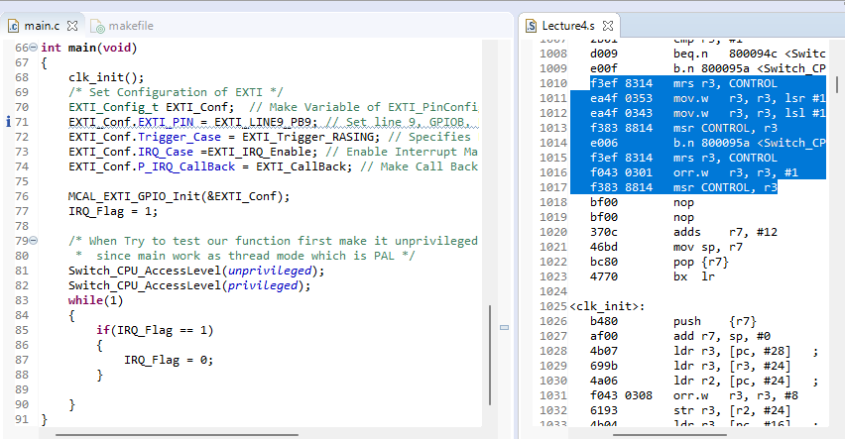

* Simulation:

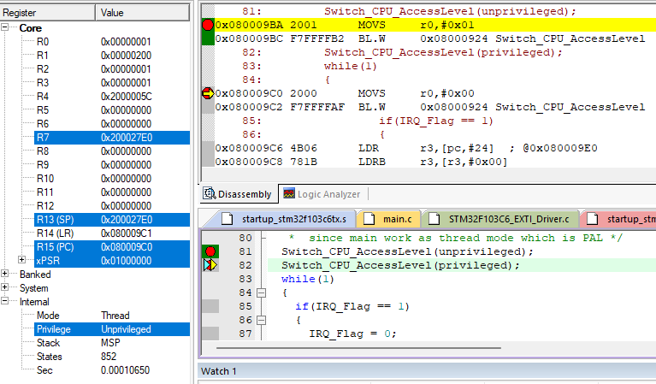

* Note:

Not allowed to write in CONTROL register when you are unprivileged, so we handle it in ISR as handler mode work as PAL to it have access to write on Control.

* **What would happen if we switched to unprivileged before configuring NVIC?**
  + Code:

* Simulation:

* Note:

The Stack branch to strange address, we find that it loops in hard fault handler because not allow to access NVIC during unprivileged.

* **Switch Between them using ISR:**
  + Code:

* + Simulation:

